**Lesson plan**

**Webster University**

**MA in TESL Group 5K**

**Curriculum Design**

**Professor: Kamola Alimova**

**Student: Yusupova Makhbuba**

**Lesson Plan**

**Date: 2021.12.03**

**Grade: 7**

Topic: I have a pain in my…..

**Aims:**

Educational: to practise explaining their feelings and health condition

Developing: -to practise new words about health

-to practise listening activity

-to practise reading activity related to the topic

-to practise a real- life situation with a role-play activity

Socia-cultural: -to improve knowledge of students about this topic

Up-bringing: -to encourage students to acquire L2 using different strategies

Learning outcome: At the end of the lesson students will be able to speak about their health problems and explain them to others

Type of the lesson: group work, pair-work, individual work

Method of the lesson : mixed

Equipment of the lesson: handouts, pictures, internet, computer and projector

**Technological map of the lesson:**

|  |  |  |  |
| --- | --- | --- | --- |
| No | Part of the lesson | Tasks | Time |
| 1 | Organizational part | Greet with students.Motivate them | 5 |
| 2 | Revise the last lesson | Remind the last lesson giving some questions | 10 |
| 3 | Explaining a new topic | Give an explanation of a new topic and introduce a new vocabulary | 10 |
| 4 | Consolidation part | Work with different activities and play games | 10 |
| 5 | Marking | Tell the mark of students | 5 |
| 6 | Homework | Give an appropriate hometask and explain it | 5 |

**Procedure of the lesson:**

1. *Organizing part:* Greeting with students, ask about attendance, give some motivation and prepare students to the lesson
2. *Asking homework:* Memorize the last lesson by giving questions and revise acquired new words
3. *Warm- up activity*

**Ativity 1**

**Objectives:** **to revise new words of the last lesson and introduce with a new vocabulary related to the state of the healt**

Students are given out worksheets and a list of new words. The students should match words and pictures and learn the pronunciation of the new words. Then they are given a list of words and the students need to find some omitted letters.

|  |  |
| --- | --- |
| photo_2021-12-03_20-39-44.jpg | photo_2021-12-03_20-45-38.jpg |

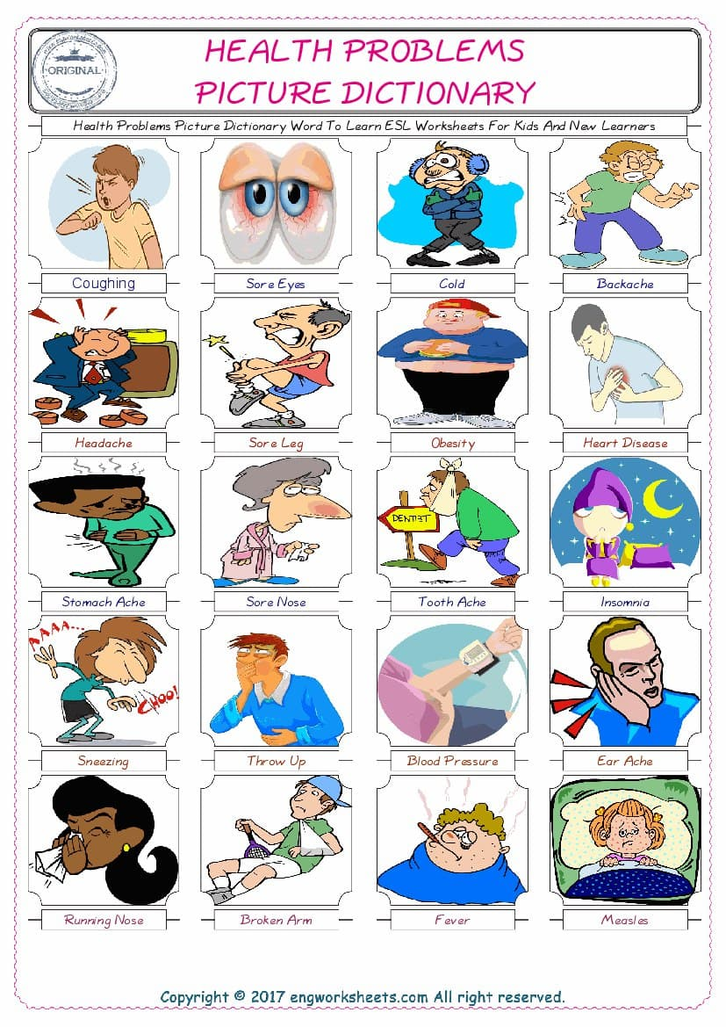

1. Main part

**Activity 2**

**Objective : to check the student’s ability of listening**

Teacher gives a clear instruction. According to this the students should listen a dialogue between two people about a health problems and the students should fill the sentences with necessary words

<https://youtu.be/JZalsqtjtB4>

**Here is the transcript of the video.**

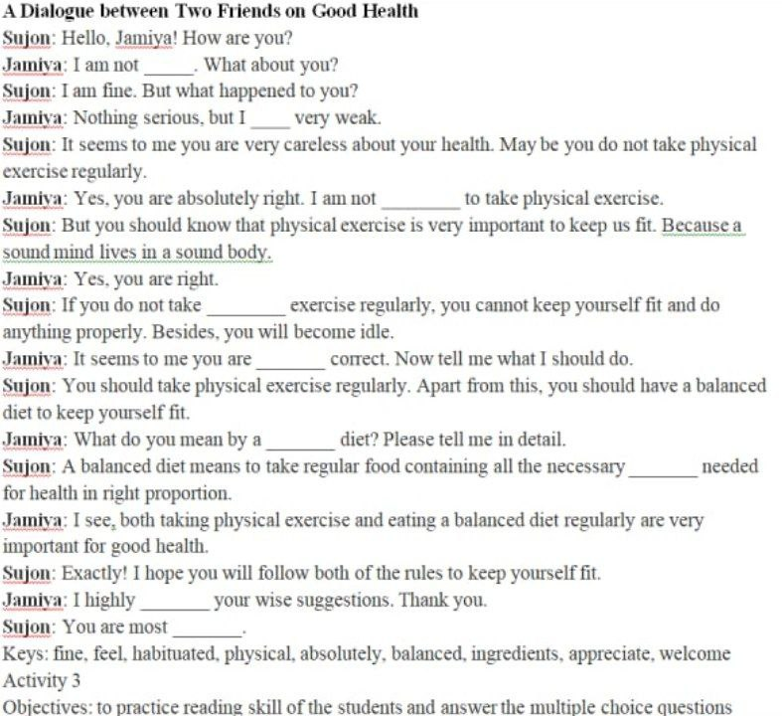

**Keys:** fine, feel, habituated, physical, absolutely, balanced, ingredients, appreciate, welcome

**Activity 3**

**Objectives: to practice reading skill of the students and answer the multiple choice questions**

Teenagers and media

Media, including print, television, film and online, can negatively affect young people in many ways, including:

* exposing them to extreme violence, which can desensitise them to reality
* supporting the cultural ideal that only thin is beautiful, which promotes body image problems
* reinforcing the importance of money, consumerism and status symbols.

Teenagers and suicide

After car accidents, suicide is the most common cause of death among young people in Australia. Research shows more young women than young men attempt suicide, but young men are far more likely to take their own lives.  
In the past 10 years, the suicide rate for males aged 15 to 24 years has dropped considerably. However, young men living in rural and remote areas are more likely than those living in the city to take their own lives.

1. What can negatively effect young people?
2. media B) books C) online learning

2. What is the main cause of the death after car accident?

A) alcohol B) suicide C) love

3. Who is more tend to kill themselves men or women?

A) both of them B) men C) women

4. Young men living\_\_\_\_\_\_and remote areas are more likely than those living in the city to take their own lives.

A) in rural B) in urban C) in cities

5 Post –activity

**Activity 4**

**Objectives: to practise different health conditions in the real life using a role-play activity.**

The students are divided into 2 groups. One by one they come to the blackboard and show the bad condition of the people described in the pictures to the members of the other group. The more group members find the conditions, the more score they are given.

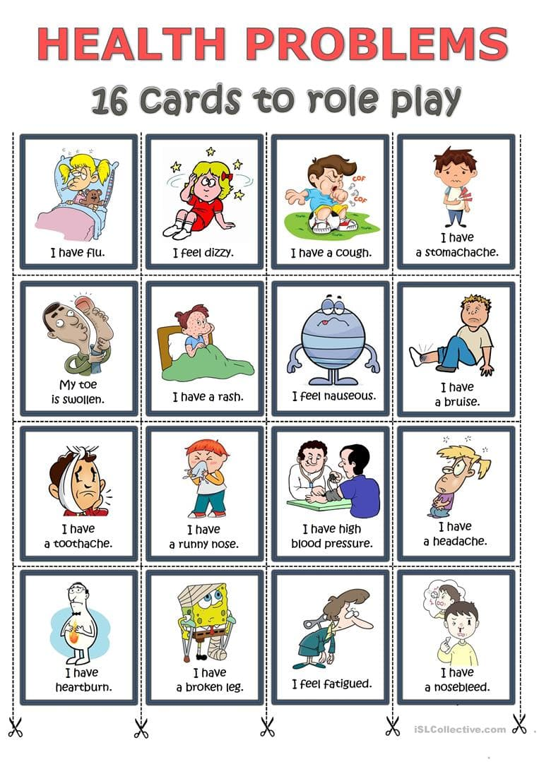

Homework

Ask the students to learn new words at home and make new sentences using them. Then they need to organize different groups and make up a dialogue.

Evaluation: The students are marked and motivated one more time

**Appendix 1**

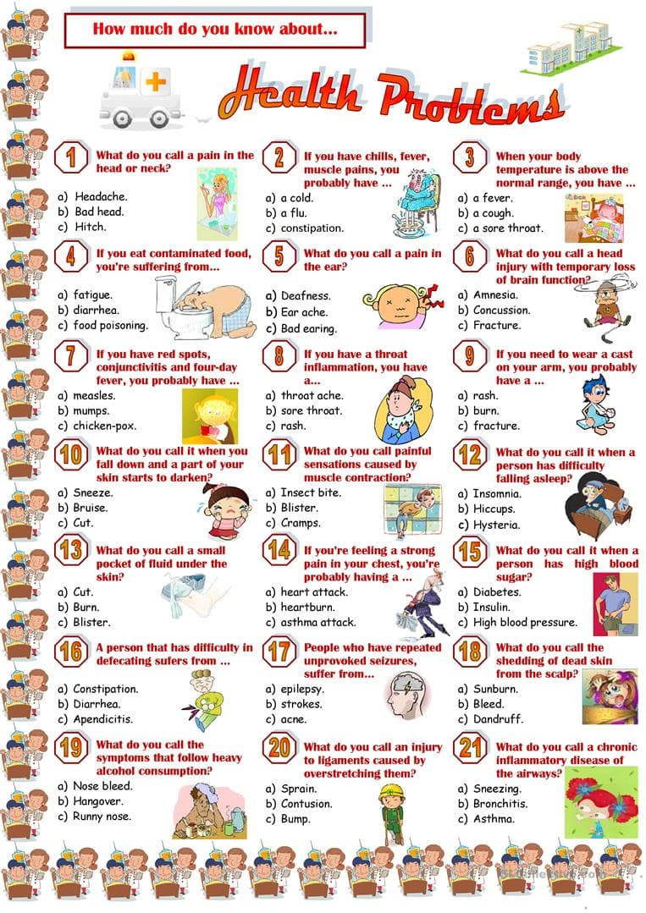

**Appendix 2**

**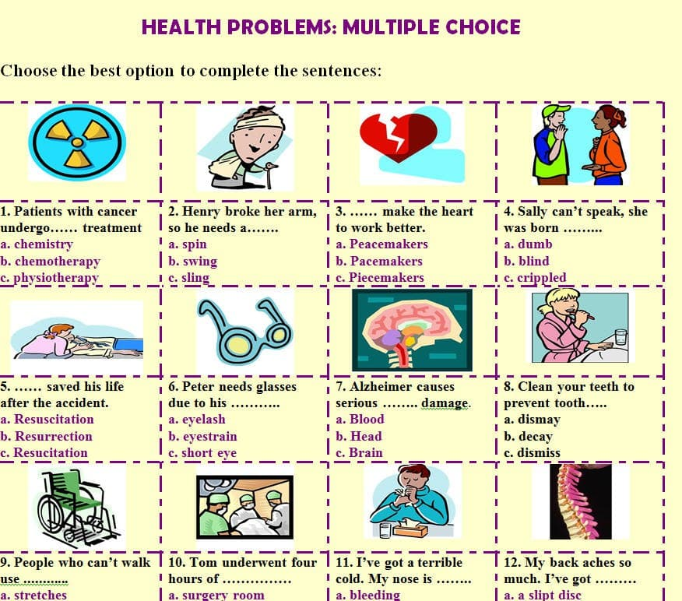**

**Appendix 3**

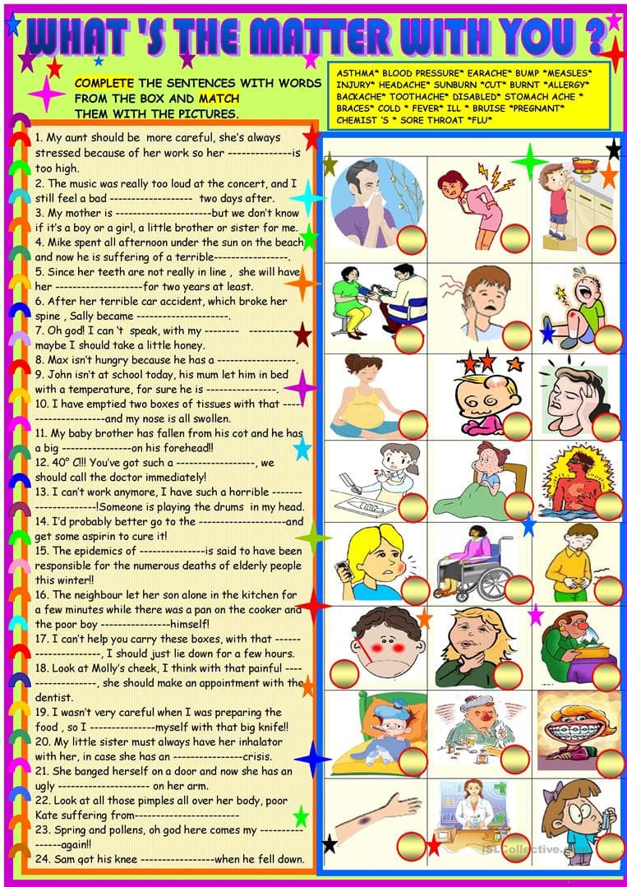

**Reference**

Ismailov, T., & Yusupova, M. (2022). Insonga psixologik ta’sir ko’rsatish turlari va texnikasi. *Science and Education*, *3*(6), 913-920.

Yusupova, M. (2021). Distance learning of foreign languages. *Экономика и социум*, (8 (87)), 84-87.

Yusupova, M. (2024). LEVERAGING ENGLISH TERMINOLOGICAL DICTIONARIES TO AUGMENT COMMUNICATION SKILLS IN MUSIC EDUCATION STUDENTS. *Молодые ученые*, *2*(12), 140-141.

Yusupova, M. (2024). UTILIZING THE ENGLISH TERMINOLOGICAL DICTIONARY TO ENHANCE THE COMMUNICATION SKILLS OF MUSIC EDUCATION STUDENTS. *Theoretical aspects in the formation of pedagogical sciences*, *3*(9), 98-101.

Yusupova, M. (2023). OLIY TA’LIMDA CHET TILINI MASOFAVIY O'QITISH SIFATINI OSHIRISH OMILLARI. *Молодые ученые*, *1*(16), 16-17.

Yusupova, M. (2024). THE CULTURAL IMPACT OF MUSIC IN ENGLISH. *Nordic\_Press*, *5*(0005).

Yusupova, M. (2024). MONTESSORI SINFLARIDA INGLIZ TILIDA GAPIRISH VA ESHITISH KO ‘NIKMALARINI RIVOJLANTIRISH USULLARI. *Педагогика и психология в современном мире: теоретические и практические исследования*, *3*(13), 58-62.

Yusupova, M. (2024). ChatGPT and Language Models: A New Era in Linguistic Communication. *Nordic\_Press*, *3*(0003).

Yusupova, M. (2024). The Blended Learning: Combining Traditional and Digital Approaches in ESL Classrooms:" Enhancing Language Acquisition through a Seamless Integration of In-Class and Online Learning Strategies". *Nordic\_Press*, *3*(0003).

Yusupova, M., & Ismailov, T. (2024). Integration of Artificial Intelligence (AI) in ELT. *Nordic\_Press*, *3*(0003).

Yusupova, M. (2024). MUSIQA TA’LIMI TALABALARIGA INGLIZ TILINI O ‘QITISHDA MUSIQIY MATERILLARDAN FOYDALANISH. *Nordic\_Press*, *5*(0005).

Yusupova, M. (2024). SUN’IY INTELLEKT VA MASHINAVIY TARJIMA. *Nordic\_Press*, *3*(0003)